Database Management System
EXPERIMENT 9 SUBQUERIES

NAME : MOHAMED FUZAIL A
ROLL NO : 241801162
- Display employees in the same department as Zlotkey (excluding Zlotkey)

SELECT last_name, hire_date
FROM employees
WHERE department_id = (
SELECT department_id
FROM employees
WHERE last_name = 'Zlotkey'
)AND last_name <> 'Zlotkey';

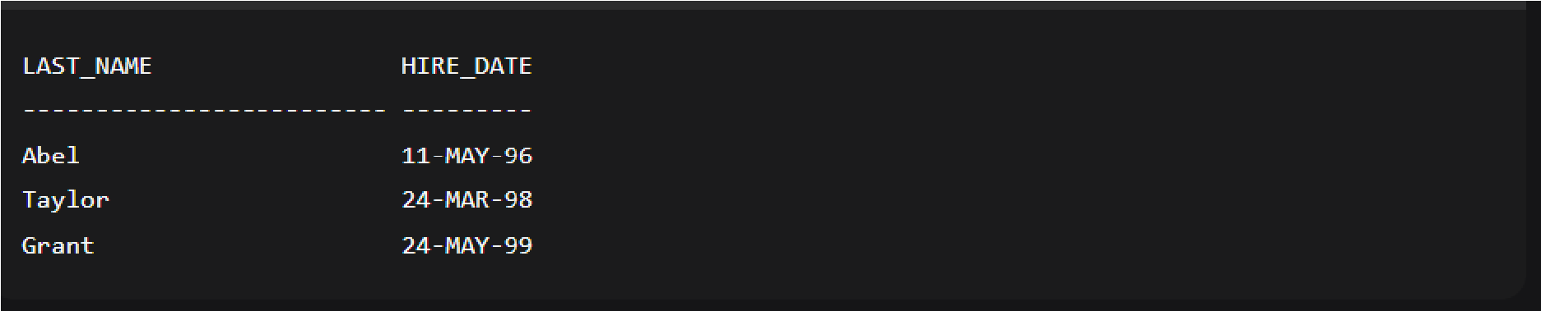
- Display employees earning more than average salary

SELECT employee, last name, salary
FROM employees
WHERE salary > (SELECT AVG (salary) FROM employees)
ORDER BY salary ASC;

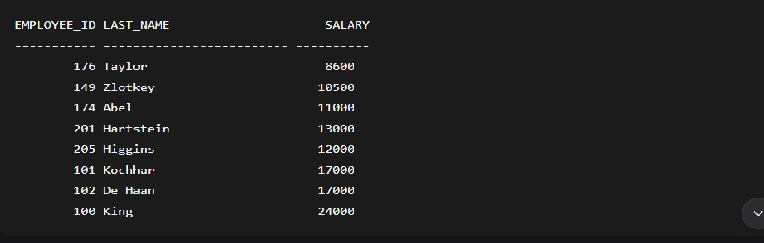

- Display employees working in departments with employees having 'u' in last name
SELECT employee_id, last_name
FROM employees WHERE department_id IN (
SELECT DISTINCT department_id
FROM employees WHERE last_name LIKE '%u%' )
ORDER BY employee_id;

OUTPUT:

EMPLOYEE_ID LAST_NAME

  - Russell
  - Partners
  - Errazuriz
  - Cambrault
  - Zlotkey
  - Tucker
  - Bernstein
  - Hall
  - Olsen
  - Cambrault
  - Tuvault
  - King
  - Sully
  - McEwen
  - Smith
  - Doran
  - Sewall
  - Vishney 163 Greene
  - Marvins
  - Lee
  - Ande
  - Banda 168 Ozer
169 Bloom 170 Fox
  - Smith
  - Bates
  - Kumar
  - Abel
  - Hutton
  - Taylor
  - Livingston
  - Grant 179 Johnson

- Display employees in location ID 1700

SELECT e.last_name, e.department_id, e.job_id
FROM employees e JOIN departments d ON e.department_id = d.department_id WHERE d.location_id = 1700 ORDER BY e.last_name;

